

**RESPONSE TO**

**YOGENDRAN**

**ONLINE CAB(CAR) BOOKING APPLICATION**

**SOFTWARE PROPOSAL**



SUBMISSION BY:

**EVERLASTING INFOTECH PVT LTD**

ONLINE CAB(CAR) BOOKING APPLICATION

## TA B L E O F C O N T E N T S

INTRODUCTION 3

* PROJECT OBJECTIVES 3

PROPOSED TIMELINE/SCHEDULE 4

* STAGE 1 – CONCEPT DEVELOPMENT 4
* STAGE 2 – PLANNING 4
* STAGE 3 – DEVELOPMENT 4
* STAGE 4 – TESTING 5
* STAGE 5 – LAUNCH AND PHASE OUT 5

PRICING 7

* ACCEPTANCE OF PROPOSAL 8

# PROJECT OBJECTIVES

A taxicab, also known as a taxi or a cab, is a type of [vehicle for hire](https://en.wikipedia.org/wiki/Vehicle_for_hire) with a driver, used by a single passenger or small group of passengers, often for a non-shared ride. A taxicab conveys passengers between locations of their choice. This differs from other modes of [public transport](https://en.wikipedia.org/wiki/Public_transport) where the pick-up and drop-off locations are decided by the service provider, not by the customers, although [demand responsive transport](https://en.wikipedia.org/wiki/Demand_responsive_transport) and [share taxis](https://en.wikipedia.org/wiki/Share_taxi) provide a hybrid bus/taxi mode.

## P R O P O S E D T I M E L I N E / S C H E D U L E

# STAGE 1 – CONCEPT DEVELOPMENT

As per the discussion which was occurred earlier this week, we will start the development activity once the PO get sign off.

# STAGE 2 – PLANNING

As per the discussion which was occurred earlier this week, we will start the development activity once the PO get sign off.

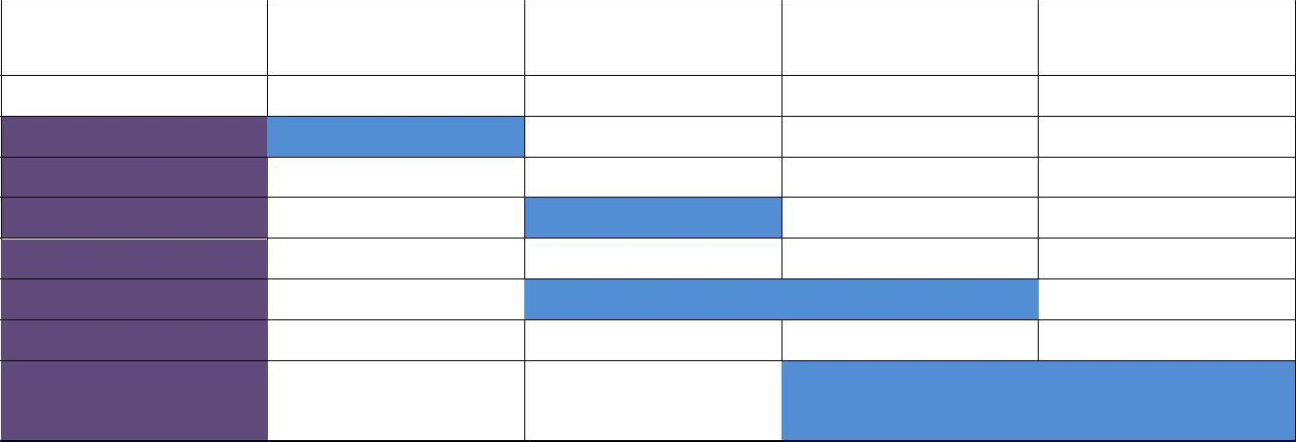

Planning Design Coding

Testing &

Delivery

|  |  |  |  |  |
| --- | --- | --- | --- | --- |
| Activates / Month | 1 | 2 to 4 | 4 to 8 | 8 to 10 |
|  |  | | | |

# STAGE 3 – DEVELOPMENT

As per the planning our technical team will start designing, designing phase will take place for two weeks of time, once design phase was over design will be get approved from the client. After getting approval out team will start coding, Coding will take place for two weeks from the date of design get approved.

# STAGE 4 –TESTING

Once the coding part is get over, now software was ready for testing phase. Out testing will perform testing of each and every screen and functions. Once testing phase was over in the development environment, software was sent to the client for user acceptance testing (UAT). Once UAT successfully signed off we will take to the implementation phase.

# STAGE 5 – LAUNCH AND PHASE OUT

Once the testing part gets over, now software was ready for deployment.

Finally, Production display deployed at the user end and phase out for usage.

**Stage 1 – Concept Development**

|  |  |
| --- | --- |
| **Step** | **Description** |
| 1. Request for Proposal (RFP) | ONLINE CAR(CAB) BOOKING APPLICATION description of project; begins to formalize the website concept and design. Define the scope. |
| 2. Proposal | Developer’s written estimate of the schedule and cost of project. |
| 3. Contract/Budget Approval | ONLINE CAR(CAB) BOOKING APPLICATION, Developer agree in writing to proceed with the project. |

**Stage 2 – Planning**

|  |  |
| --- | --- |
| **Step** | **Description** |
| 4. Product Requirement (Project Plan) | Submit written plan to ONLINE CAR(CAB) BOOKING APPLICATION. Includes general project overview and goals, resource/staffing plan, testing plan, milestones, and other tactical details. Forms basis for Project Definition Meeting. |
| 5. Project Definition Meeting | Meeting between key players from ONLINE CAR(CAB) BOOKING APPLICATION, Developer. Group agrees on exactly what will be included in the website and how it is presented, on a detailed section-by-section basis. Implementation begins after this meeting. **Please Note: After the client has signed off on the creative and structural definitions, any changes may affect the timeline and/or the budget of the project.** |
| 6. Project Specification | Developer completes specific written description of project as defined in Project Definition Meeting. ONLINE CAR(CAB) BOOKING APPLICATION approves Product Specification. Changes after this date require Change Order Form and may incur additional charges. |

**Stage 3 – Development & Implementation**

|  |  |
| --- | --- |
| **Step** | **Description** |
| 7. Content Acquisition | ONLINE CAR(CAB) BOOKING APPLICATION supplies digital data and other content sources. Developer converts content into application formats. |
| 8. Data Integration | Developer imports and integrates data content into website. |
| 9. Customization | Developer creates unique graphics and screens (pages) for the website. Custom programming begins. |
| 10. Server Set-Up | Developer assists set up of Web Server, domain, and options. |

**Stage 4 – Testing**

|  |  |
| --- | --- |
| **Step** | **Description** |
| 11. Alpha Testing (Staging) | Developer begins internal testing of application functionality. Bugs are systematically reported and fixed. |
| 12. Beta Testing (Staging) | Developer validates the content and finalize live project with review by ONLINE CAR(CAB) BOOKING APPLICATION. ONLINE CAR(CAB) BOOKING APPLICATION reports any bugs, signs off fixes, and approves site for launch. |

**Stage 5 – Launch and Phase Out**

|  |  |
| --- | --- |
| **Step** | **Description** |
| 13. Activation | Website goes live. |
| 14. Project Review | Everlasting InfoTech Pvt Ltd internal project review (non-billable time). Feedback requested from ONLINE CAR(CAB) BOOKING APPLICATION. |
| 15. Admin/Support | Maintenance work by Everlasting InfoTech Pvt Ltd begins. |

## P R I C I N G

Everlasting InfoTech Pvt Ltd software as developers provides the following estimate to develop the Online car(cab) booking application.

**DEVELOPMENT OF ONLINE CAR(CAB) BOOKING APPLICATION.**

Everlasting InfoTech Pvt Ltd provides the following production elements for development:

* Project definition includes operating schedule, technical specifications and storyboard development.
* Production includes import content, image conversion/file set-up.
* Images provided by Yogendran will be optimized for web presentation.
* Custom programming - research and testing.
* Creation of custom request and input forms.
* HTML page construction.
* Graphic design and customization.
* On-site server set up.

**Total Cost: ₹ 44, 10,000* +Tax**

**Cost Breakup:**

* **Website**
  + **Development**

|  |  |
| --- | --- |
| **:** | **₹ 12,00,000** |
| **:** | **₹ 5,00,000** |
| **:** | **₹ 4,00,000** |
| **:** | **₹ 1,00,000** |
| **:** | **₹22,00,000*+Tax** |
| **:** | **₹ 10,00,000** |
| **:** | **₹ 6,50,000** |
| **:** | **₹ 5,00,000** |
| **:** | **₹21,50,000*+Tax** |

* + **Testing**
  + **Deployment**
  + **Training**
    - **Total**
* **Mobile Application (Android)**
  + **Development**
  + **Testing**
  + **Deployment**
    - **Total**
  + **Others(PaymentGateway,Bulksms,**

**GPS Google Api,Cloud Database : ₹ 1,60,000**

**Domain name & hosting)**

* + - **Total : ₹ 1,60,000**

**Overall Total : ₹ ₹44,10,000*+Tax**

**Note:** This cost is for the module and screens in the appendix and also tax not included in this. Above given amount was excluding from tax.

# ACCEPTANCE OF PROPOSAL

Signing the Services Agreement in the Appendix indicates acceptance of this proposal.

Employee Training Management Proposal

## A P P E N D I X

**MODULES DETAILS**

# EMPLOYEE TRAINING MANAGEMENT SOFTWARE

* **Trainee**
  + Dashboard for their online exam details
  + Profile
  + Summary
  + Feedback screen

# Supervisor

* + Feedback evaluation
  + Attendance (read access only)
  + Feedback screen
  + Fix the lunch time for calculating training duration.
  + Reports.
  + Main screen.
  + Question upload.
  + Profile.

# Admin

* All access
* Final approval for employee
* Training pop up (Monthly, Weekly, Day wise)
* Nomination confirmation
* Reports
* Attendance.
* Main screen.
* Question upload
* Profile.

Employee Training Management Proposal

## S E RV I C E S A G R E E M E N T

The undersigned on behalf of Mando automotive india pvt ltd authorizes Everlasting InfoTech Pvt Ltd Software, Inc. to commence work as outlined in the project described in this document. The client agrees to pay a commitment deposit in the amount of 30% of the proposal price with an additional 30% due at the commencement of beta testing and the balance plus all applicable taxes due on sign-off at project review (not exceeding 30 days of the project posting date). The client further agrees to review and sign-off project in-progress reports upon confirmation of milestone performance as defined in the project document.

Dated this day of , 20

for MANDO AUTOMOTIVE INDIA PVT LIMITED for the Developer

Employee Training Management Proposal



# PROJECT SIGN-OFF SHEET



|  |  |
| --- | --- |
| **Milestone** | **Signatures** |
| Proposal Acceptance  Date | For Mando Automotive India Pvt. Ltd.  For Developer |
| Website Design/ Structure Completed  Date | For Mando Automotive India Pvt. Ltd.  For Developer |
| Back-end Mgt Interface Completed  Date | For Mando Automotive India Pvt. Ltd.  For Developer |
| QA & Roll-Out Completed  Date | For Mando Automotive India Pvt. Ltd.  For Developer |
|  |  |